
CSI3105 Software Testing
Workshop 9: Monkey Patching Reinforcement
Tasks from this workshop must be completed. Some of these tasks will contribute to your ability to complete the Assessments.
Related to Learning Outcomes:
- Apply different test case design techniques, recognising the strength and weakness of each and being able to choose techniques appropriately.
Learning outcomes:
- To develop your skills in handling user inputs while testing in Python

This workshop covers:
- Monkey patching revisited
What is monkeypatching?
Monkeypatching is a technique used in testing to dynamically change or replace parts of your application at runtime. This includes functions, methods, classes, or environment variables. It's especially useful for isolating the code under test by replacing dependencies with mocks or controlled responses.
In pytest, the monkeypatch fixture makes this easy and safe. You can use it to override attributes, dictionaries, or environment variables temporarily during a test.
Monkeypatching is ideal for:
- Replacing external dependencies
- Mocking I/O operations or APIs
- Controlling test environments without permanent changes

Part 0: Getting Started
- Get the workshop code from Canvas.
- Install pytest
  - File -> Settings -> Project: x -> Python Interpreter -> hit the + icon and search pytest -> install pytest
  - 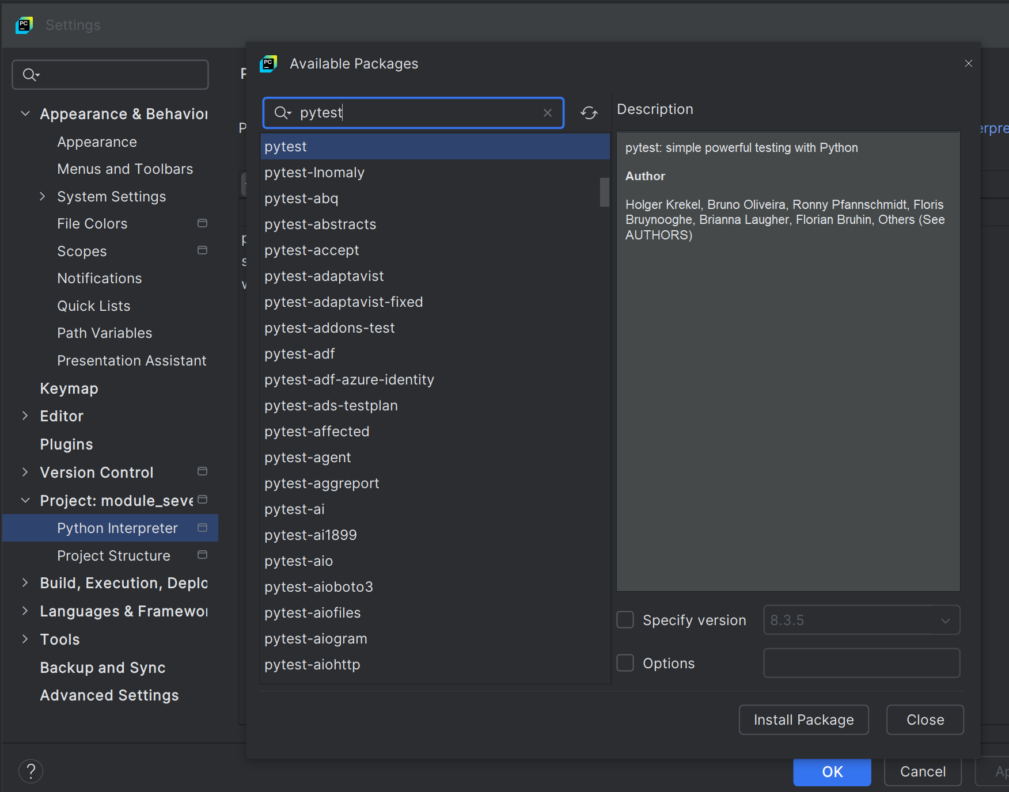

  - Ensure that module_nine is marked as sources root by right clicking the folder, going to mark directory as and select sources root.

Question One:
Write a new test case for collect_user_details() where the user’s name is "Bob", age is "45", email is "bob@example.com", and country is "Canada".
- In tests.test_input_handler.py, create a new test method based on test_collect_user_details to reflect the above information.
- 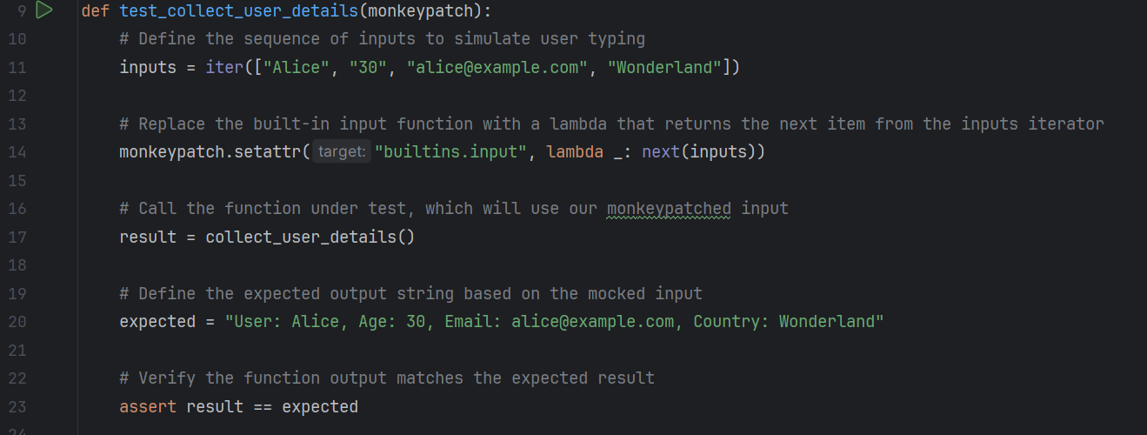

Question Two:
Modify the collect_user_details() function to return a dictionary instead of a string. Then update your existing test case accordingly using monkeypatch.
- collect_user_details() currently returns a formatted string
- Return this information as a dictionary
- Change your test case to assert the expected result is a dictionary rather than a string

Question Three:
Add a new menu option (4) to the menu_system() function called "Tell a Joke" that prints "Why did the developer go broke? Because he used up all his cache.". Then write a new test for this option using monkeypatch and capsys.
- Update the menu_system() code in input_handler.py
- When the user selects the new menu option 4, print the above joke
- Write a new test case that provides the menu option 4 via monkey patching and captures the console output with capsys.
- Assert the correct joke is returned.

Question Four:
Refactor menu_system() so it loops until "3" is entered. Then write a test that uses monkeypatch with an iterator to simulate the following inputs: "invalid", "4", "3". Use capsys to assert that each expected message appears in the output.

